***Maze Ball Game***

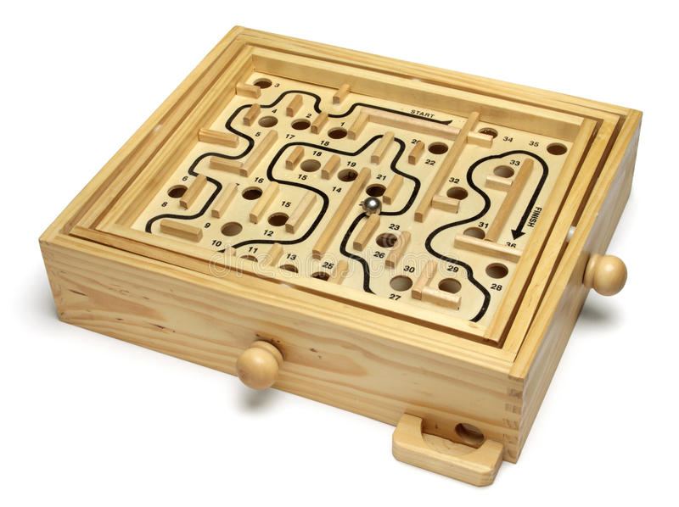

*The maze ball game is made of wood. This toy is suitable for children or as a stress reliever in a group of friends.*